Report by Joynal Abedin

# Documentation

**5.1 Nessus Vulnerability Scanner**

I skipped this section with Prof. Schott’s permission.

**5.2 SAINT vulnerability Scanner**

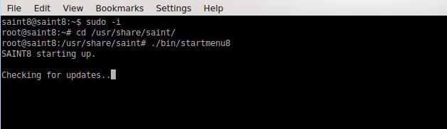

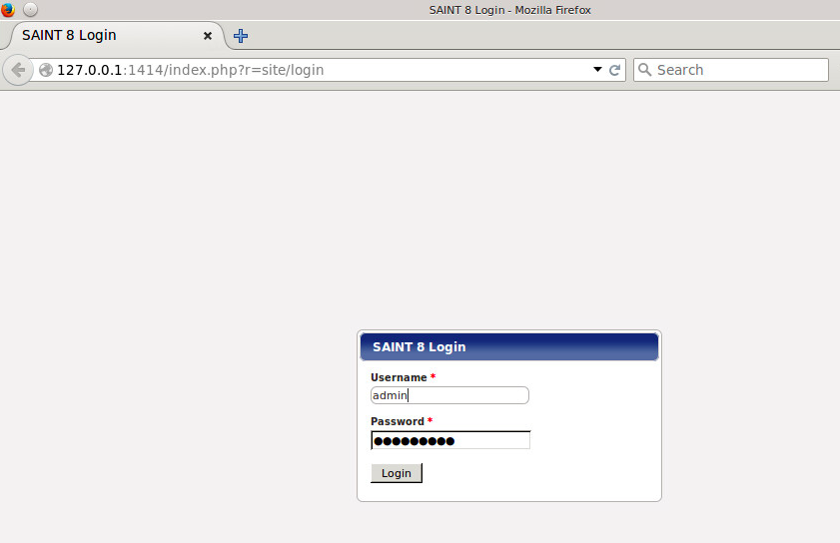

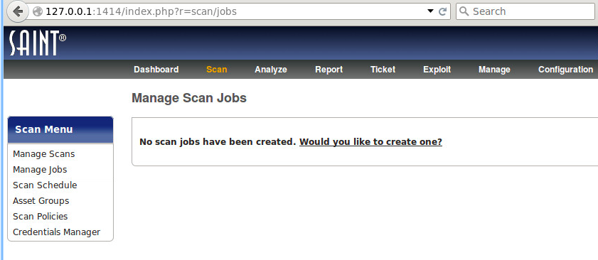

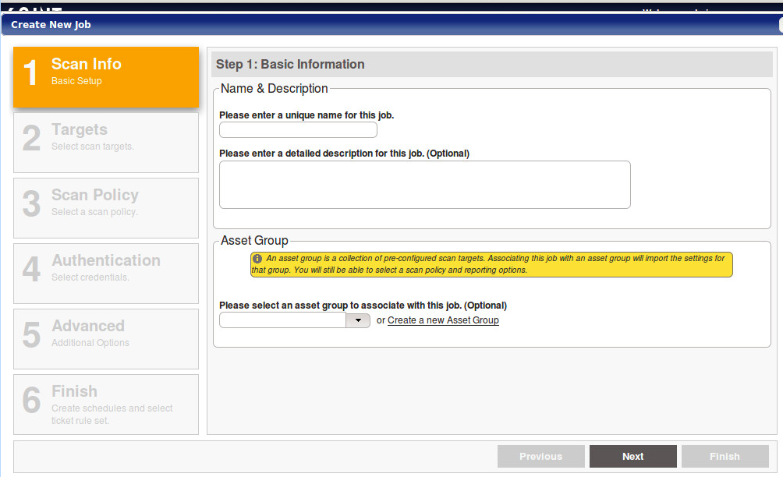

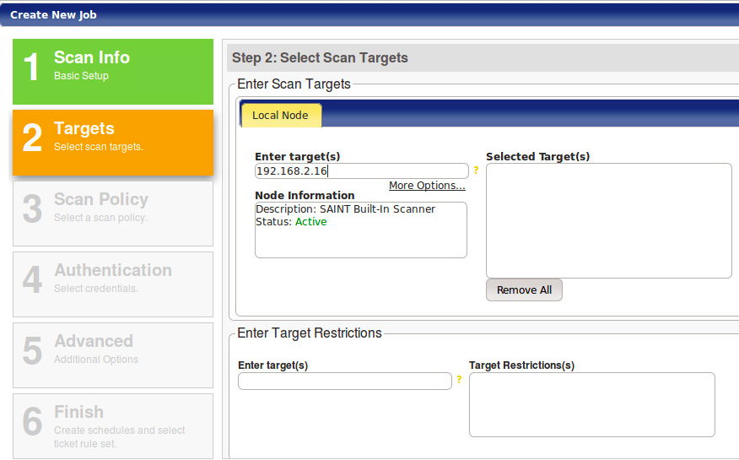

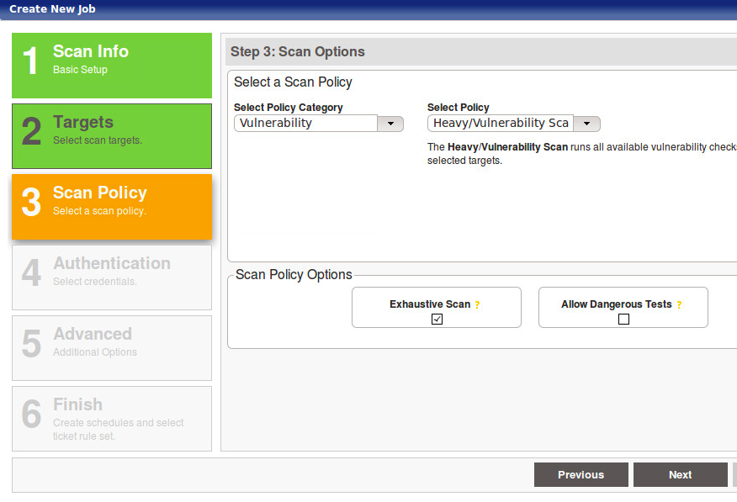

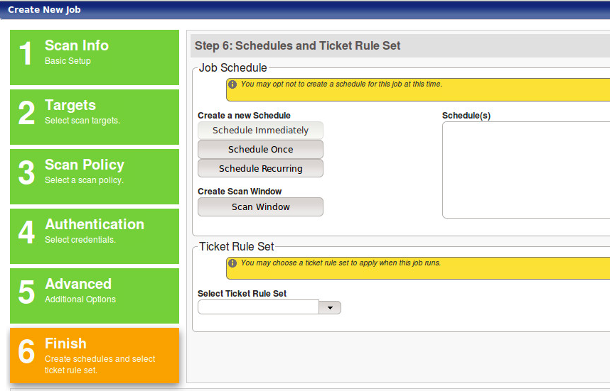

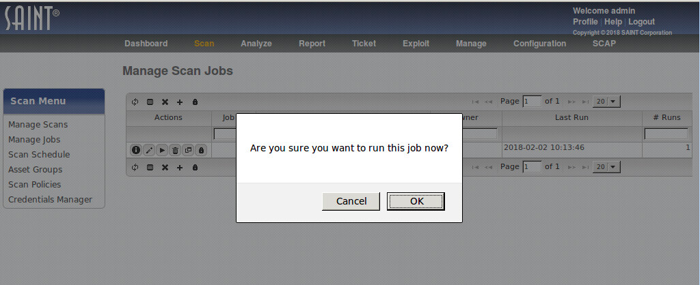

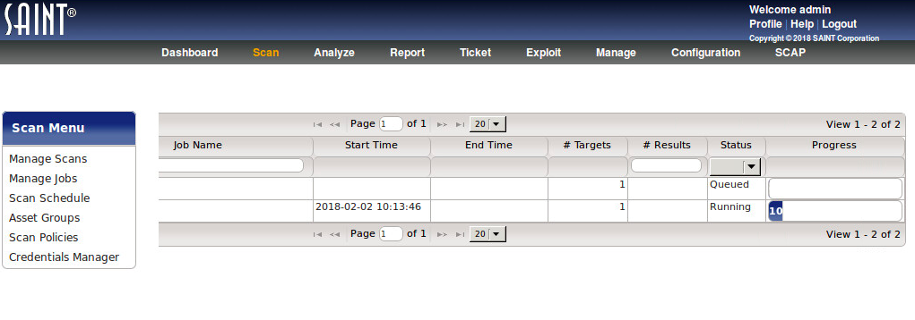

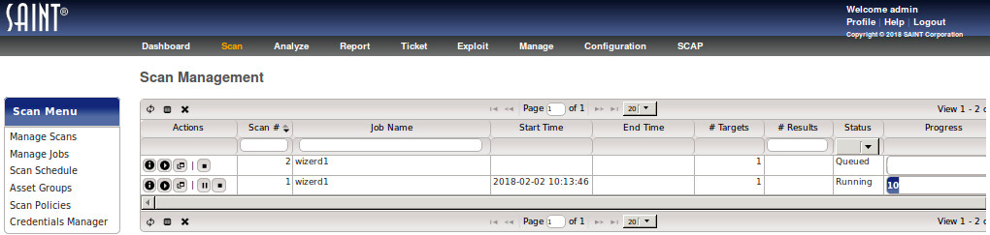

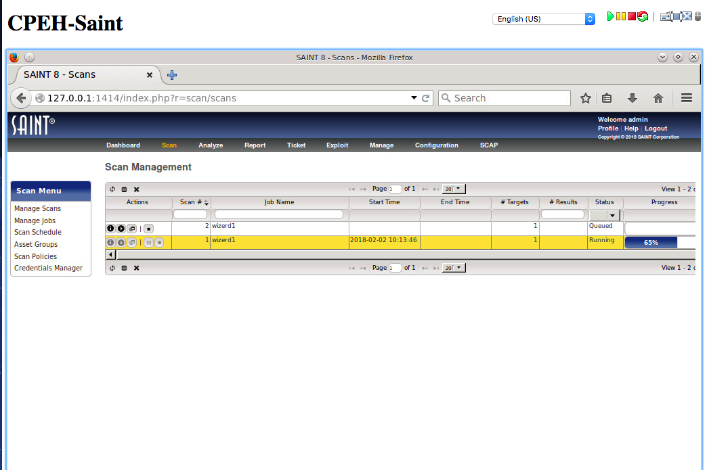

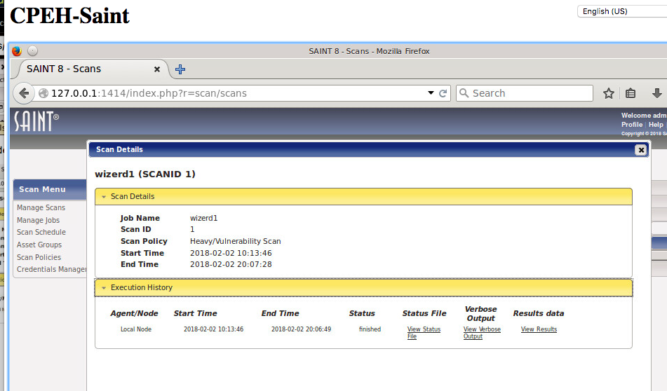

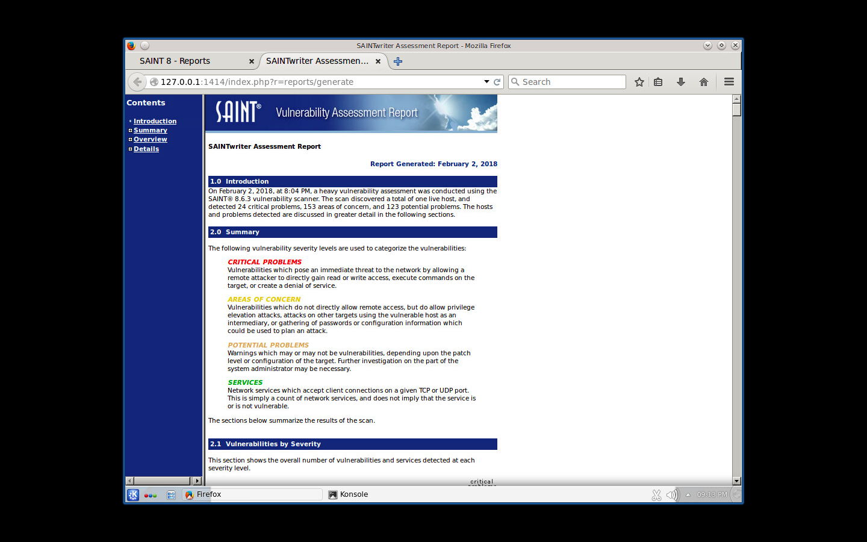

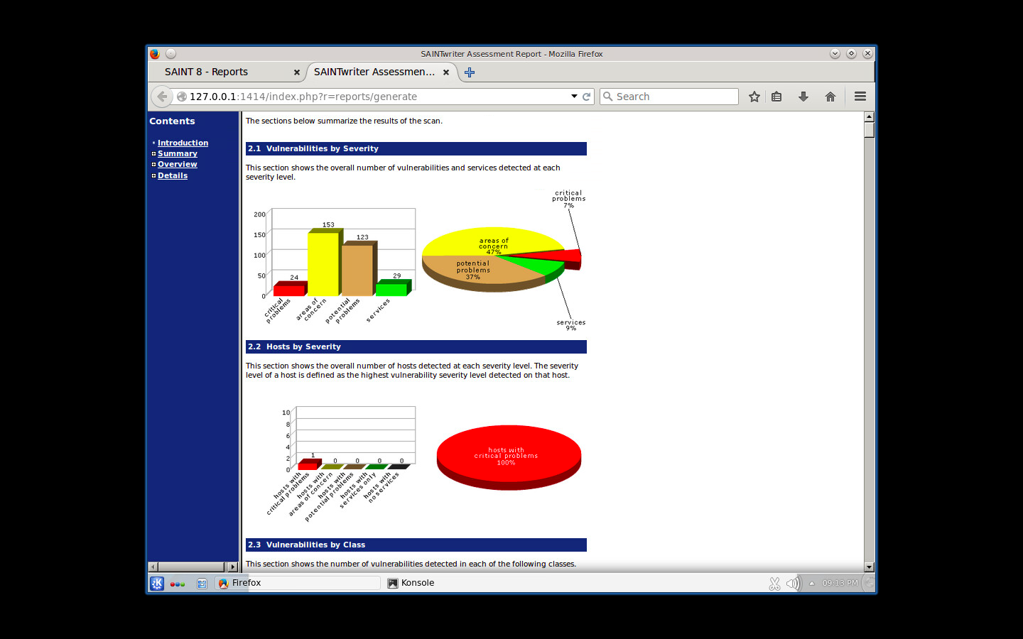

# Vulnerabilities

## Vulnerability 01

### Description

Someone from remote location can gain access and execute any commands or crash the file server.

### Relative Risk (High, Medium, Low)

* High
  + Approximately 10 times more expensive than a “medium“ risk
  + Although threat is high it will not require additional budget

### Mitigation

Update the apache server to the latest version and problem will be solved.